**EE 499 – Lab 2**

Question 1)

Request for Comments (RFC) is a formal document from the Internet Engineering Task Force (IETF) that is the result of committee drafting and subsequent review by interested parties, some RFCs are informational.

**RFC 7252** – Constrained Application Protocol (CoAP)

* Title: The Constrained Application Protocol (CoAP)

**RFC 768** – User Datagram Protocol (UDP)

* Title: User Datagram Protocol

**RFC 6553** – Routing Protocol for Low-Power and Lossy Networks (RPL)

* Title: The Routing Protocol for Low-Power and Lossy Networks (RPL) Option for Carrying RPL Information in Data-Plane Datagrams

**RFC 6550 or RFC 2460** – IPv6

* Title for RFC 6550: RPL: IPv6 Routing Protocol for Low-Power and Lossy Networks
* Title for RFC 2460: Internet Protocol, Version 6 (IPv6) Specification

**RFC 777 or RFC 792** – Internet Control Message Protocol (ICMP)

* Title for RFC 777: Internet Control Message Protocol
* Title for RFC 792: Internet Control Message Protocol, DARPA Internet Program Protocol Specification

**RFC 4919 or RFC 4944** – IPv6 over Low-Power Wireless Personal Area Networks (6LoWPANs)

* Title for RFC 4919: IPv6 over Low-Power Wireless Personal Area Networks (6LoWPANs): Overview, Assumptions, Problem Statement, and Goals
* Title for RFC 4944: Transmission of IPv6 Packets over IEEE 802.15.4 Networks

Question 2)

int rss = (int)(hdr->rssi)-(int)CC2538_RSSI_OFFSET

printf(“RSS is %d \n”,rss);

Question 3)

float prr = (double)pkt_rcv/(double)num_pkts;

printf(“PRR is %f \n”,prr);

Question 4)

|  |  |
| --- | --- |
| PRR | Distance (m) |
| 1 | 1 |
| 1 | 3 |
| 1 | 5 |
| 1 | 7 |
| 0.9 | 10 |
| 0.8 | 15 |
| 0.6 | 20 |
| 0.1 | 25 |

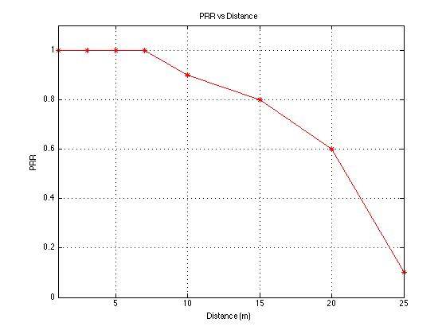

Question 5)

Question 6)

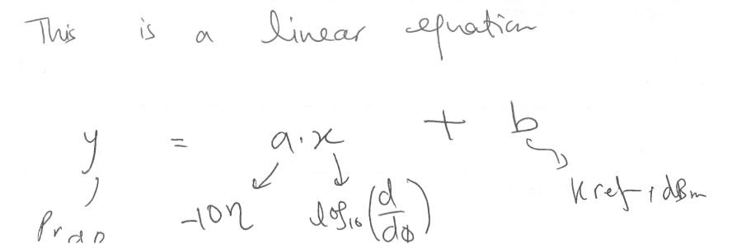

According to the linear equation from the lecture notes:

*a* = -1.1955

-n = -1.1955

n = 1.1955

Therefore, the path loss coefficient for my experiment is 1.1955.